Chapter 12

Distributed Database Management Systems

Discussion Focus

Discuss the possible data request scenarios in a distributed database environment.

1. Single request accessing a single remote database. (See Figure D12.1.)

Figure D12.1 Single Request to Single Remote DBMS
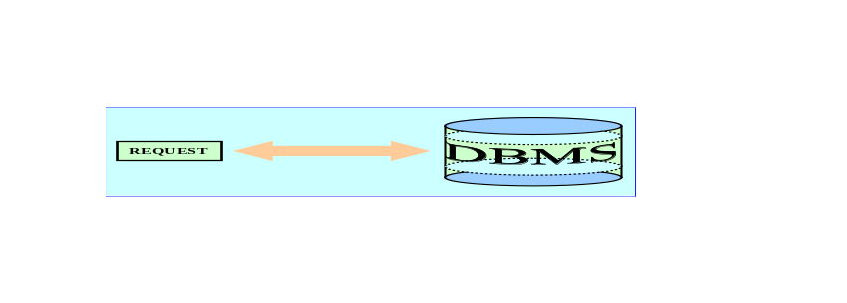

The most primitive and least effective of the distributed database scenarios is based on a single SQL statement (a "request" or "unit of work") is directed to a single remote DBMS. (Such a request is known as a remote request.). We suggest that you remind the student of the distinction between a request and a transaction:
- A request uses a single SQL statement to request data.
- A transaction is a collection of two or more SQL statements.

2. Multiple requests accessing a single remote database. (See Figure D12.2.)

Figure D12.2 Multiple Requests to a Single Remote DBMS
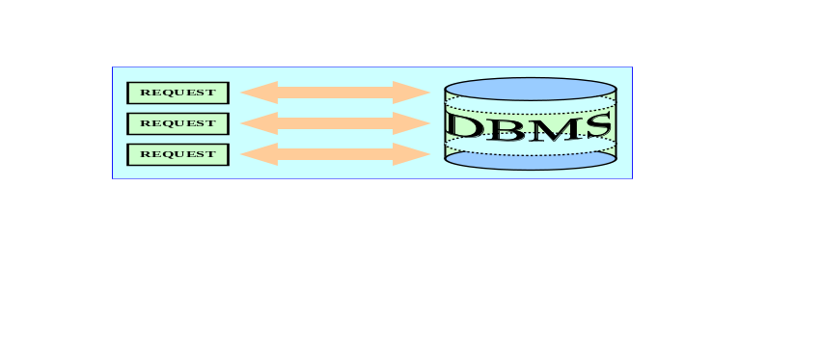
A unit of work now consists of multiple SQL statements directed to a single remote DBMS. The local user defines the start/stop sequence of the units of work, using COMMIT, but the remote DBMS manages the unit of work's processing.

3. Multiple requests accessing multiple remote databases. (See Figure D12.3.)

Figure D12.3 Multiple requests, Multiple Remote DBMSes
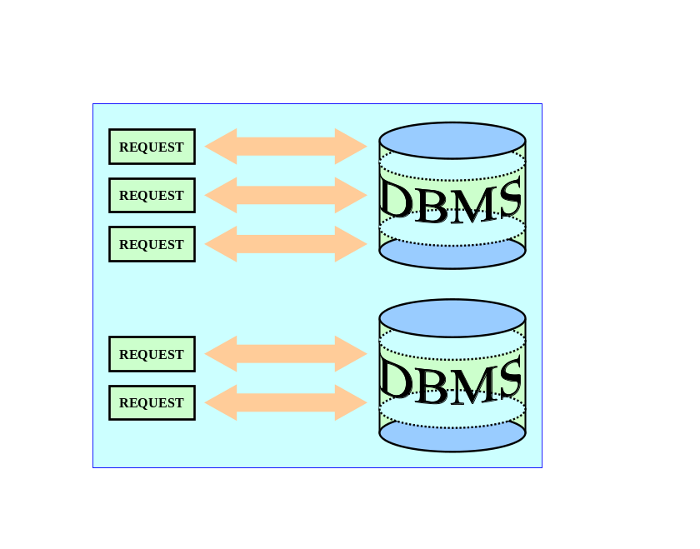

A unit of work now may be composed of multiple SQL statements directed to multiple remote DBMSes. However, any one SQL statement may access only one of the remote DBMSes. As was true in the second scenario, the local user defines the start/stop sequence of the units of work, using COMMIT, but the remote DBMS to which the SQL statement was directed manages the unit of work's processing. In this scenario, a two-phase COMMIT must be used to coordinate COMMIT processing for the multiple locations.

4. Multiple requests accessing any combination of multiple remote DBMSes. (See Figure D12.4.)

Figure D12.4 Multiple Requests and any Combination of Remote Databases
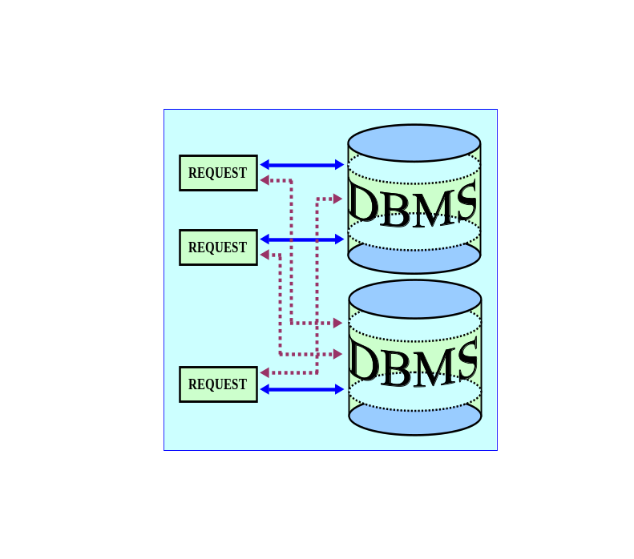

A unit of work now may consist of multiple SQL statements addressed to multiple remote DBMSes, and each SQL statement may address any combination of databases. As was true in the third scenario, each local user defines the start/stop sequence of the units of work, using COMMIT, but the remote DBMS to which the SQL statement was directed manages the unit of work's processing. A two-phase COMMIT must be used to coordinate COMMIT processing for the multiple locations.

Remaining discussion focus:

The review questions cover a wide range of distributed database concept and design issues. The most important questions to be raised are:
- What is the difference between a distributed database and distributed processing?
- What is a fully distributed database management system?
- Why is there a need for a two-phase commit protocol, and what are these two phases?
- What does "data fragmentation" mean, and what strategies are available to deal with data fragmentation?
- Why and how must data replication be addressed in a distributed database environment? What replication strategies are available, and how do they work?
- Since the current literature abounds with references to file servers and client-server architectures, what do these terms mean? How are file servers different from client/server architectures? Why would you want to know?

We have answered these questions in detail in the Answers to Review Question section of this chapter. Note particularly the answers to questions 5, 6, 11, and 15-17.

NOTE
Many questions raised in this section are more specific -- and certainly more technical -- than the questions raised in the previous chapters. Since the chapter covers the answers to these questions in great detail, we have elected to give you section references to avoid needless duplication.

Answers to Review Questions

- Describe the evolution from centralized DBMSs to distributed DBMSs.

This question is answered in detail in section 12-1.

- List and discuss some of the factors that influenced the evolution of the DDBMS.

These factors are listed and discussed in section 12-1.

- What are the advantages of the DDBMS?

See section 12-2 and Table 12.1.

- What are the disadvantages of the DDBMS?

See section 12-2 and Table 12.1.

- Explain the difference between distributed database and distributed processing.

See section 12-3.

- What is a fully distributed database management system?

See section 12-4.

- What are the components of a DDBMS?

See section 12-5.

- List and explain the transparency features of a DDBMS.

See section 12-7.

- Define and explain the different types of distribution transparency.

See section 12-8.

10. Describe the different types of database requests and transactions.

A database transaction is formed by one or more database requests. Each database request is the equivalent of a single SQL statement. The basic difference between a local transaction and a distributed transaction is that the latter can update or request data from several remote sites on a network. In a DDBMS, a database request and a database transaction can be of two types: remote or distributed.

NOTE
The figure references in the discussions refer to the figures found in the text.

Note: The figure references in the discussions refer to the figures found in the text. The figures are not reproduced in this manual.

A remote request accesses data located at a single remote database processor (or DP site). In other words, an SQL statement (or request) can reference data at only one remote DP site. Use Figure 12.9 to illustrate the remote request.

A remote transaction, composed of several requests, accesses data at only a single remote DP site. Use Figure 12.10 to illustrate the remote transaction.

As you discuss Figure 12.10, note that both tables are located at a remote DP (site B) and that the complete transaction can reference only one remote DP. Each SQL statement (or request) can reference only one (the same) remote DP at a time; the entire transaction can reference only one remote DP; and it is executed at only one remote DP.

A distributed transaction allows a transaction to reference several different local or remote DP sites. Although each single request can reference only one local or remote DP site, the complete transaction can reference multiple DP sites because each request can reference a different site. Use Figure 12.11 to illustrate the distributed transaction.

A distributed request lets us reference data from several different DP sites. Since each request can access data from more than one DP site, a transaction can access several DP sites. The ability to execute a distributed request requires fully distributed database processing because we must be able to:
- Partition a database table into several fragments.
- Reference one or more of those fragments with only one request. In other words, we must have fragmentation transparency.
The location and partition of the data should be transparent to the end user. Use Figure 12.12 to illustrate the distributed request.

As you discuss Figure 12.12, note that the transaction uses a single SELECT statement to reference two tables, CUSTOMER and INVOICE. The two tables are located at two different remote DP sites, B and C.

The distributed request feature also allows a single request to reference a physically partitioned table. For example, suppose that a CUSTOMER table is divided into two fragments C1 and C2, located at sites B and C respectively. The end user wants to obtain a list of all customers whose balance exceeds $250.00. Use Figure 12.13 to illustrate this distributed request.

Note that full fragmentation support is provided only by a DDBMS that supports distributed requests.

- Explain the need for the two-phase commit protocol. Then describe the two phases.

See section 12-9c.

- What is the objective of the query optimization functions?

The objective of query optimization functions is to minimize the total costs associated with the execution of a database request. The costs associated with a request are a function of:
- the access time (I/O) cost involved in accessing the physical data stored on disk
- the communication cost associated with the transmission of data among nodes in distributed database systems
- the CPU time cost.

It is difficult to separate communication and processing costs. Query-optimization algorithms use different parameters, and the algorithms assign different weight to each parameter. For example, some algorithms minimize total time, others minimize the communication time, and still others do not factor in the CPU time, considering it insignificant relative to the other costs. Query optimization must provide distribution and replica transparency in distributed database systems.

- To which transparency feature are the query optimization functions related?

Query-optimization functions are associated with the performance transparency features of a DDBMS. In a DDBMS the query-optimization routines are more complicated because the DDBMS must decide where and which fragment of the database to access. Data fragments are stored at several sites, and the data fragments are replicated at several sites.

- What issues should be considered when resolving data requests in a distributed environment?

A data request could be either a read or a write request. However, most requests tend to be read requests. In both cases, resolving data requests in a distributed data environment most consider the following issues:
- Data distribution.
- Data replication.
- Network and node availability.
A more detailed discussion of these factors can be found in section 12-10.

- Describe the three data fragmentation strategies. Give some examples of each.

See section 12-11a.

- What is data replication, and what are the three replication strategies?

See section 12-11b.

- What are the two basic styles of data replication?

There are basically two styles of replication:
- Push replication. In this case, the originating DP node sends the changes to the replica nodes to ensure that all data are mutually consistent.
- Pull replication. The originating DP node notifies the replica nodes so they can pull the updates one their own time.
See section 12-11b for more information.

- What trade-offs are involved in building highly distributed data environments?

In the year 2000, Dr. Eric Brewer stated in a presentation that: “in any highly distributed data system there are three common desirable properties: consistency, availability and partition tolerance. However, it is impossible for a system to provide all three properties at the same time.” Therefore, the system designers have to balance the trade-offs of these properties in order to provide a workable system. This is what is known as the CAP theorem. For more information on this, see section 12-12.

- How does a BASE system differ from a traditional distributed database system?

A traditional database system enforces the ACID properties as to ensure that all database transactions yield a database in a consistent state. In a centralized database system, all data resides in a centralized node. However, in a distributed database system data are located in multiple geographically disperse sites connected via a network. In such cases, network latency and network partitioning impose a new level of complexity. In most highly distributed systems, designers tend to emphasize availability over data consistency and partition tolerance. This trade-off has given way to a new type of database systems in which data are basically available, soft state and eventually consistent (BASE).
For more information about BASE systems see section12-12.

Problem Solutions

The first problem is based on the DDBMS scenario in Figure P12.1.

Figure P12.1 The DDBMS Scenario for Problem 1
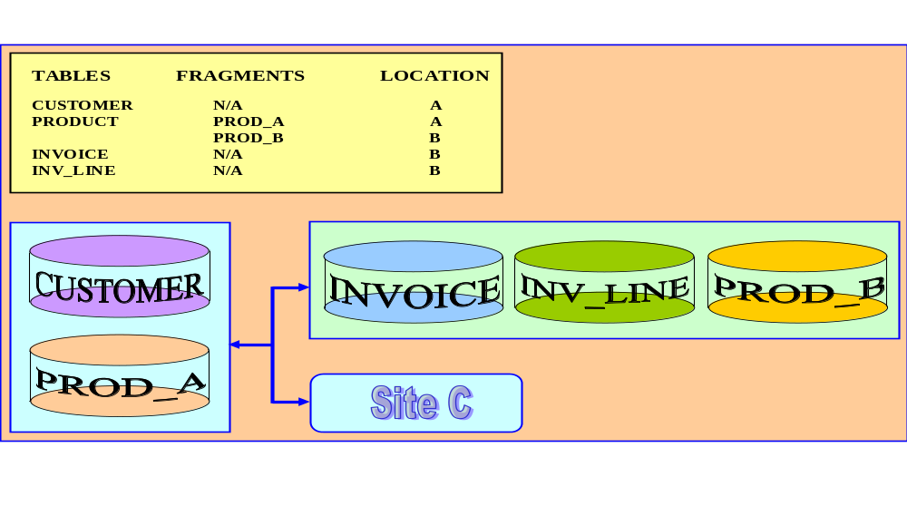

- Specify the minimum types of operations the database must support to perform the following operations. These opertaions should include remote request, remote transaction, distributed transaction, and distributed requests in order to perform the following operations.
NOTE
To answer the following questions, remind the students that the key to each answer is in the number of different data processors that are accessed by each request/transaction. Ask the students to first identify how many different DP sites are to be accessed by the transaction/request. Next, remind the students that a distributed request is necessary if a single SQL statement is to access more than one DP site.

Use the following summary:

 | Number of DPs
Operation | 1 | > 1
Request | Remote | Distributed
Transaction | Remote | Distributed

Based on this summary, the questions are answered easily.

At C:

a. SELECT *
FROM CUSTOMER;

This SQL sequence represents a remote request.

b. SELECT *
FROM INVOICE
WHERE INV_TOTAL < 1000;

This SQL sequence represents a remote request.

c. SELECT *
FROM PRODUCT
WHERE PROD_QOH < 10;

This SQL sequence represents a distributed request. Note that the distributed request is required when a single request must access two DP sites. The PRODUCT table is composed of two fragments, PRO_A and PROD_B, which are located in sites A and B, respectively.

d. BEGIN WORK;
UPDATE CUSTOMER
SET CUS_BALANCE = CUS_BALANCE + 100
WHERE CUS_NUM='10936';
INSERT INTO INVOICE(INV_NUM, CUS_NUM, INV_DATE, INV_TOTAL)
VALUES ('986391', '10936', ‘15-FEB-2018’, 100);
INSERT INTO INVLINE(INV_NUM, PROD_CODE, LINE_PRICE)
VALUES ('986391', '1023', 100);
UPDATE PRODUCT
SET PROD_QOH = PROD_QOH - 1
WHERE PROD_CODE = '1023';
COMMIT WORK;

This SQL sequence represents a distributed request.

Note that UPDATE CUSTOMER and the two INSERT statements only require remote request capabilities. However, the entire transaction must access more than one remote DP site, so we also need distributed transaction capability. The last UPDATE PRODUCT statement accesses two remote sites because the PRODUCT table is divided into two fragments located at two remote DP sites. Therefore, the transaction as a whole requires distributed request capability.

e. BEGIN WORK;
INSERT CUSTOMER(CUS_NUM, CUS_NAME, CUS_ADDRESS, CUS_BAL)
VALUES ('34210','Victor Ephanor', '123 Main St', 0.00);
INSERT INTO INVOICE(INV_NUM, CUS_NUM, INV_DATE, INV_TOTAL)
VALUES ('986434', '34210', ‘10-AUG-2018’, 2.00);
COMMIT WORK;

This SQL sequence represents a distributed transaction. Note that, in this transaction, each individual request requires only remote request capabilities. However, the transaction as a whole accesses two remote sites. Therefore, distributed request capability is required.

At A:

f. SELECT CUS_NUM, CUS_NAME, INV_TOTAL
FROM CUSTOMER, INVOICE
WHERE CUSTOMER.CUS_NUM = INVOICE.CUS_NUM;

This SQL sequence represents a distributed request. Note that the request accesses two DP sites, one local and one remote. Therefore distributed capability is needed.

g. SELECT *
FROM INVOICE
WHERE INV_TOTAL > 1000;

This SQL sequence represents a remote request, because it accesses only one remote DP site.

h. SELECT *
FROM PRODUCT
WHERE PROD_QOH < 10;

This SQL sequence represents a distributed request. In this case, the PRODUCT table is partitioned between two DP sites, A and B. Although the request accesses only one remote DP site, it accesses a table that is partitioned into two fragments: PROD-A and PROD-B. A single request can access a partitioned table only if the DBMS supports distributed requests.

At B:

i. SELECT *
FROM CUSTOMER;

This SQL sequence represents a remote request.

j. SELECT CUS_NAME, INV_TOTAL
FROM CUSTOMER, INVOICE
WHERE INV_TOTAL > 1000 AND CUSTOMER.CUS_NUM = INVOICE.CUS_NUM;

This SQL sequence represents a distributed request.

k. SELECT *
FROM PRODUCT
WHERE PROD_QOH < 10;

This SQL sequence represents a distributed request. (See explanation for part h.)

2. The following data structure and constraints exist for a magazine publishing company.

a. The company publishes one regional magazine each in Florida (FL), South Carolina (SC), Georgia (GA), and Tennessee (TN).

b. The company has 300,000 customers (subscribers) distributed throughout the four states listed in Part 2a.

c. On the first of each month, an annual subscription INVOICE is printed and sent to each customer whose subscription is due for renewal. The INVOICE entity contains a REGION attribute to indicate the customer’s state of residence (FL, SC, GA, TN):

CUSTOMER (CUS_NUM, CUS_NAME, CUS_ADDRESS, CUS_CITY, CUS_STATE, CUS_ZIP,
CUS_SUBSDATE)

INVOICE (INV_NUM, INV_REGION, CUS_NUM, INV_DATE, INV_TOTAL)

The company is aware of the problems associated with centralized management and has decided that it is time to decentralize the management of the subscriptions in its four regional subsidiaries. Each subscription site will handle its own customer and invoice data. The management at company headquauters, however, will have access to customer and invoice data to generate annual reports and to issue ad hoc queries, such as:
- List all current customers by region.
- List all new customers by region.
- Report all invoices by customer and by region.

Given these requirements, how must you partition the database?

The CUSTOMER table must be partitioned horizontally by state. (We show the partitions in the answer to 3c.)

3. Given the scenario and the requirements in Problem 2, answer the following questions:

a. What recommendations will you make regarding the type and characteristics of the required database system?

The Magazine Publishing Company requires a distributed system with distributed database capabilities. The distributed system will be distributed among the company locations in South Carolina, Georgia, Florida, and Tennessee.

The DDBMS must be able to support distributed transparency features, such as fragmentation transparency, replica transparency, transaction transparency, and performance transparency. Heterogeneous capability is not a mandatory feature since we assume there is no existing DBMS in place and that the company wants to standardize on a single DBMS.

b. What type of data fragmentation is needed for each table?

The database must be horizontally partitioned, using the STATE attribute for the CUSTOMER table and the REGION attribute for the INVOICE table.

c. What must be the criteria used to partition each database?

The following fragmentation segments reflect the criteria used to partition each database:

Horizontal Fragmentation of the CUSTOMER Table by State

Fragment Name | Location | Condition | Node name
C1 | Tennessee | CUS_STATE = 'TN' | NAS
C2 | Georgia | CUS_STATE = 'GA' | ATL
C3 | Florida | CUS_STATE = 'FL' | TAM
C4 | South Carolina | CUS_STATE = 'SC' | CHA

Horizontal Fragmentation of the INVOICE Table by Region

Fragment Name | Location | Condition | Node name
I1 | Tennessee | REGION_CODE = 'TN' | NAS
I2 | Georgia | REGION_CODE = 'GA' | ATL
I3 | Florida | REGION_CODE = 'FL' | TAM
I4 | South Carolina | REGION_CODE = 'SC' | CHA
d. Design the database fragments. Show an example with node names, location, fragment names, attribute names, and demonstration data.

Note the following fragments:

Fragment C1 Location: Tennessee Node: NAS
CUS_NUM | CUS_NAME | CUS_ADDRESS | CUS_CITY | CUS_STATE | CUS_SUB_DATE
10884 | James D. Burger | 123 Court Avenue | Memphis | TN | 8-DEC-16
10993 | Lisa B. Barnette | 910 Eagle Street | Nashville | TN | 12-MAR-17

Fragment C2 Location: Georgia Node: ATL
CUS_NUM | CUS_NAME | CUS_ADDRESS | CUS_CITY | CUS_STATE | CUS_SUB_DATE
11887 | Ginny E. Stratton | 335 Main Street | Atlanta | GA | 11-AUG-16
13558 | Anna H. Ariona | 657 Mason Ave. | Dalton | GA | 23-JUN-17

Fragment C3 Location: Florida Node: TAM
CUS_NUM | CUS_NAME | CUS_ADDRESS | CUS_CITY | CUS_STATE | CUS_SUB_DATE
10014 | John T. Chi | 456 Brent Avenue | Miami | FL | 18-NOV-16
15998 | Lisa B. Barnette | 234 Ramala Street | Tampa | FL | 23-MAR-17

Fragment C4 Location: South Carolina Node: CHA
CUS_NUM | CUS_NAME | CUS_ADDRESS | CUS_CITY | CUS_STATE | CUS_SUB_DATE
21562 | Thomas F. Matto | 45 N. Pratt Circle | Charleston | SC | 2-DEC-16
18776 | Mary B. Smith | 526 Boone Pike | Charleston | SC | 28-OCT-17

Fragment I1 Location: Tennessee Node: NAS
INV_NUM | REGION_CODE | CUS_NUM | INV_DATE | INV_TOTAL
213342 | TN | 10884 | 1-NOV-15 | 45.95
209987 | TN | 10993 | 15-FEB-16 | 45.95

Fragment I2 Location: Georgia Node: ATL
INV_NUM | REGION_CODE | CUS_NUM | INV_DATE | INV_TOTAL
198893 | GA | 11887 | 15-AUG-15 | 70.45
224345 | GA | 13558 | 1-JUN-16 | 45.95

Fragment I3 Location: Florida Node: TAM
INV_NUM | REGION_CODE | CUS_NUM | INV_DATE | INV_TOTAL
200915 | FL | 10014 | 1-NOV-15 | 45.95
231148 | FL | 15998 | 1-MAR-16 | 24.95

Fragment I4 Location: South Carolina Node: CHA

INV_NUM | REGION_CODE | CUS_NUM | INV_DATE | INV_TOTAL
243312 | SC | 21562 | 15-NOV-15 | 45.95
231156 | SC | 18776 | 1-OCT-16 | 45.95

e. What type of distributed database operations must be supported at each remote site?

To answer this question, you must first draw a map of the locations, the fragments at each location, and the type of transaction or request support required to access the data in the distributed database.

 |  | Node
Fragment | NAS | ATL | TAM | CHA | Headquarters
CUSTOMER | C1 | C2 | C3 | C4
INVOICE | I1 | I2 | I3 | I4
Distributed Operations Required | none | none | none | none | distributed request

Given the problem's specifications, you conclude that no interstate access of CUSTOMER or INVOICE data is required. Therefore, no distributed database access is required in the four nodes. For the headquarters, the manager wants to be able to access the data in all four nodes through a single SQL request. Therefore, the DDBMS must support distributed requests.

f. What type of distributed database operations must be supported at the headquarters site?

See the answer for part e.

